

عنوان البحث

........................................................................................................................................................................

|  |  |
| --- | --- |
| كلـــــــــــــــية | : الهندسة الالكترونية بمنوف |
| القســم/الشعبة | :عام |
| الفرقـة/المستوي | :الأولى |
| اســــم المقـــرر | :Electrical Measurement |
| كــــود المقــــرر | : ACE 125 |
| اســـــم الطالب | :عبدالرحمن عمادالدين محمد الشافعي |
| الرقـــم القومي | :30004301700253 |
| البريد الأكاديمي | :ab.al.shafei@el-eng.menofia.edu.eg |
| اشـــــــــــــراف | : أ.د./ جمعة ذكي  : أ.د./ ابراهيم عبدالحميد |

**Abstract**

Oscilloscope which used to be called an oscillograph and we like to call it a scope or o-scope, CRO, or DSO is one of the most important devices we use everyday in our life. We can use it to measure A.C (Alternating Current) and D.C (Direct Current) voltage. We can also use it to study the waveforms of A.C voltages and to find the frequency of A.C (Alternating Current) voltage.

**Introduction**

The Cathode Ray Oscilloscope (CRO) is an important lab tool we use to display, measure and analyze a waveform and other quantities in electrical and electronic circuits. CROs are very fast X-Y plotters, displaying an input signal versus another signal or versus time. This plotter consists of a luminous spot that moves over the display surface as a response to an input voltage signal. This luminous spot is made of a beam of electrons hitting a fluorescent screen. The extremely low inertial effects related to the beam of electrons allows such a beam to be used following the changes in momentary values of rapidly changing voltages. CRO uses a horizontal input voltage that is an internally produced slope voltage which we call time base. The horizontal voltage makes the luminous spot moves periodically in a horizontal way from left to right over the display screen. CROs provide a means of visualizing time-varying voltage. Thus, they have become a universal tool in all kinds of electrical and electronic inspections.

**Research Project Contents**

Oscilloscope, an instrument which plots the relations among two or more variable quantities, with the horizontal axis usually a function of time and the vertical axis usually a function of the voltage produced by an input voltage signal. Because almost any physical phenomenon can be converted into a corresponding electric voltage with the help of a transducer, the oscilloscope is a diverse tool in all models of physical interrogation. The German physicist Ferdinand Braun designed the first known cathode-ray oscilloscope (CRO) back in 1897. How fast the response of the oscilloscope is the oscilloscope’s merit over other plotting instruments. General oscilloscopes have plotting frequencies of about 100 MHz. Response times of about 2,000 MHz are attainable with special and high-speed oscilloscopes. The oscilloscope is a widely used instruments thanks to its varies features and applications like commercial, engineering, and scientific applications, television-production engineering, and electronics design.

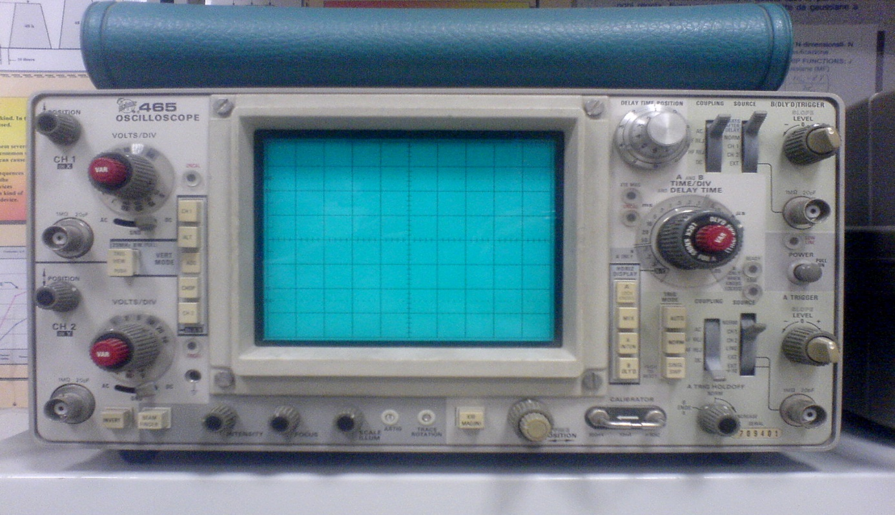

Figure-1 Oscilloscope

**Block Diagram of a Cathode Ray Tube (CRT):**

Cathode Ray Tube (CRT) is the major part of the CRO. It generates the electron beam, accelerates the beam to a high velocity, deflects the beam to create the image and contains a phosphor screen where the electron beam eventually becomes visible. The phosphor screen is encapsulated with aquadag (Aquadag is a trade name for a water-based colloidal graphite coating commonly used in cathode ray tubes.) to collect the secondary emitted electrons. To fulfil these tasks, different electrical signals and voltages are needed, which are offered by the power supply circuit of the oscilloscope. Low voltage supply is needed for the heater of the electron gun for production of electron beam and high voltage, of the order of few thousand volts, is needed for cathode ray tube to accelerate the beam. Normal voltage supply, like a few hundred volts, is required for other control circuits of the oscilloscope. Horizontal and vertical deflecting plates are fitted between the electron gun and screen to deflect the beam according to the input signal. The electron beam strikes the screen and creates a visible spot. This spot is deflected on the screen in the horizontal direction (X-axis) with constant time dependent rate. This is accomplished by a time base circuit provided in the oscilloscope. The signal to be viewed is supplied to the vertical deflection plates through the vertical amplifier, which raises the potential of the input signal to a level that will provide usable deflection of the electron beam. Now electron beam deflects in two directions, horizontal on X-axis and vertical on Y-axis. A triggering circuit is provided for synchronizing two types of deflections so that horizontal deflection starts at the same point of the input vertical signal each time it sweeps. A basic block diagram of a general-purpose oscilloscope is shown in Figure-2

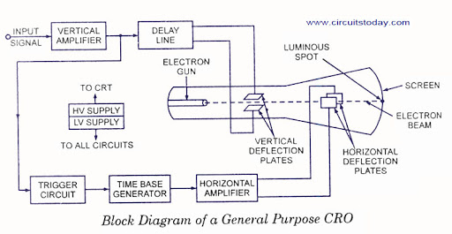

Figure-2 Block diagram of a general-purpose CRO

**The basic idea of vertical and horizontal deflection control:**The CRO is a very versatile instrument in laboratory for measurement of voltage, current, frequency and phase angle of any electrical quantity. But before we go ahead with the discussion on measurement of electrical quantities with a CRO, we should understand some basic oscilloscope patterns.

**Basic Oscilloscope Patterns:**

Assume that a sinusoidal voltage is applied to the horizontal deflecting plates without any voltage signal to the vertical deflecting plates, as shown in Figure 3.6. One horizontal line will appear on the screen of the CRO. This line would be in the central position on the screen vertically

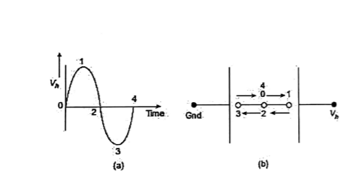

Figure-3 Deflection for a sinusoidal voltage applied to the horizontal deflection plates

If a sinusoidal voltage signal is applied to the vertical deflecting plates without applying any voltage signal to the horizontal deflecting plates then we get a vertical line on the screen of CRO, as shown in Figure 3.7. This line would be in the central position on the screen horizontally.

Now we would discuss what happens when both vertical and horizontal deflection plates are supplied with sinusoidal voltage signals simultaneously. Let us consider when two sinusoidal signals equal in magnitude and frequency and in phase with each other are applied to both horizontal and vertical deflection plates, as shown in Figure 3.8. Here we get a straight line inclined at 45° to the positive X-axis.

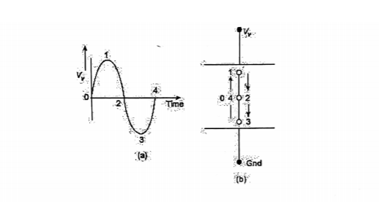

Figure-4 Deflection for a sinusoidal voltage applied to the vertical deflection plates

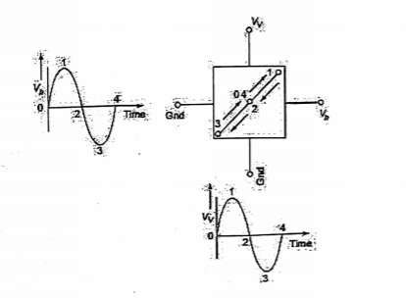

Figure-5 Deflection for sinusoidal voltage signals in phase and equal in magnitude and frequency, applied to horizontal and vertical deflection plates

Now let us consider a case when two sinusoidal voltage signals applied to the horizontal and vertical deflection plates are of equal magnitude and equal frequency but opposite in phase, as shown in Figure 3.9. We get a straight line inclined at 135° to the positive X-axis.

In the last case, if the two sinusoidal voltage signals, 90° out of phase and of equal magnitude and equal frequency, are applied to the horizontal and vertical deflection plates, a circle would appear on the screen as shown in Figure 3.10.

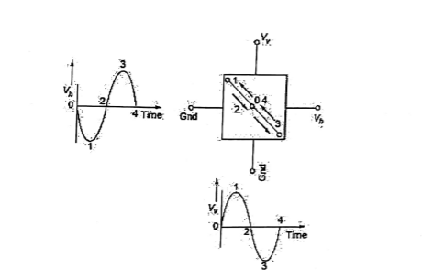

Figure-6 Deflection for sinusoidal voltage signals equal in magnitude and frequency but opposite in phase, applied to horizontal and vertical deflection plates

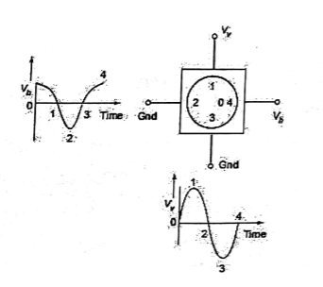

Figure-7 Deflection for sinusoidal voltage signals equal in magnitude and frequency but 90° out of phase, applied to horizontal an00d vertical deflection plates

**Triggering circuit of CRO:**

In free running sweep oscillators, it is not possible to observe the signals of variable frequency. The limitation is overcome by incorporating a trigger circuit into the oscilloscope as shown in Figure

3.5. The trigger circuit may receive an input from one of three sources depending on the setting of the trigger selector switch. The input signal may come from an external source when the trigger selector switch is e to EXT, from a low amplitude ac voltage at line frequency when the switch is set to line, or from the vertical amplifier when the switch is s to INT. When set for Internal Triggering (INT), the trigger circuit receives its input from the vertical amplifier. When the vertical input signal that is being amplified by the vertical amplifier matches a certain level, the trigger circuit provides a pulse to the sweep generator, thereby ensuring that the sweep generator output is synchronized with the signal that triggers it.

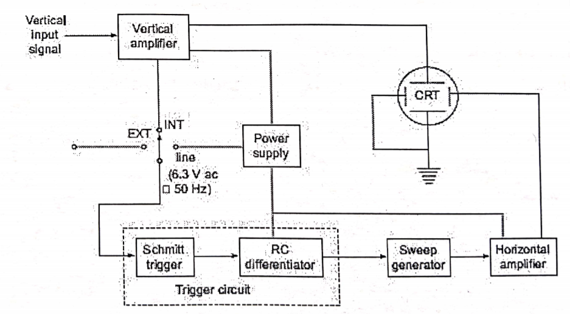

Figure-8 Block diagram of an oscilloscope with triggered

Schmitt trigger or a voltage level detector circuit is frequently used in the trigger circuit' block of Figure 3.5. Basically, the Schmitt trigger compares an input voltage, in this case from the vertical amplifier, with a pre-set voltage

**Measurement of Frequency:**

It is interesting to consider the characteristics of patterns that appear on the screen of a CRO when sinusoidal voltages are simultaneously applied to the horizontal and vertical plates. These patterns are called Lissajous patterns.

Lissajous patterns may be used for accurate measurement of frequency. The signal, whose frequency is to be measured, is applied to the Y-plates. An accurately calibrated standard variable frequency source is used to supply voltage to the X-plates, with the internal sweep generator switched off. The standard frequency is adjusted until the pattern appears as a circle or an ellipse, indicating that both signals are of the same frequency. Where it is not possible to adjust the standard signal frequency to the exact frequency of the unknown signal, the standard is adjusted to a multiple or submultiple of the frequency of the unknown source so that the pattern appears stationary.

Let us consider an example. Suppose sine waves are applied to X and Y plates as shown in Figure 3.11. Let the frequency of wave applied to Y plates is twice that of the voltage applied to the X plates. This means that the CRT spot travels two complete cycles in the vertical direction against one of the horizontal directions.

The two waves start at the same instant. A Lissajous pattern may be constructed in the usual way and a 8 shaped pattern with two loops is obtained. If the two waves do not start at the same instant. we get different pattern for the same frequency ratio. The Lissajous pattern for the other frequency ratios can be similarly drawn. Some of these patterns are in Figure 3.12.

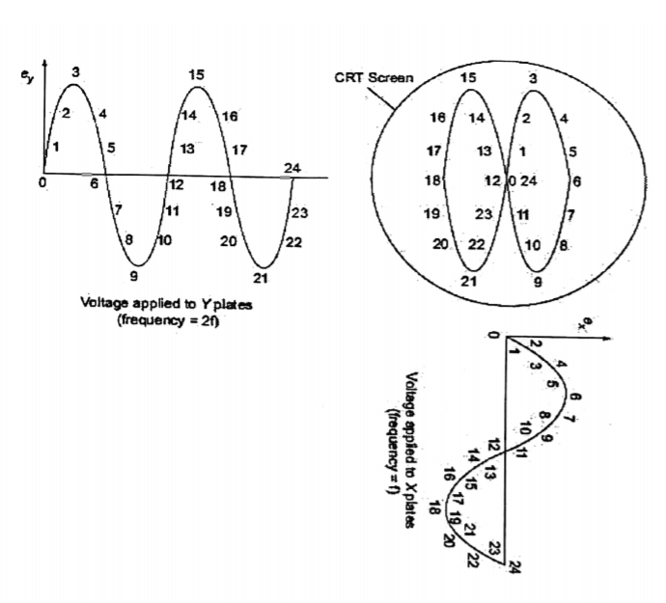

Figure-9 Lissajous pattern with frequency ratio 2:1

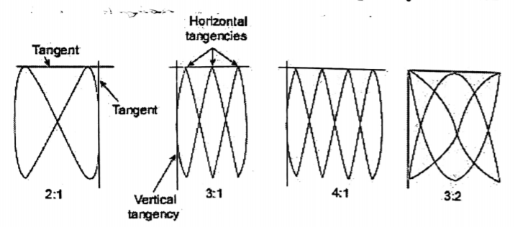

Figure-11 Lissajous patterns with different frequency ratio

It can be shown that for all the above cases, the ratios of the two frequencies is

where = Frequency of signal applied to Y plates

= Frequency of signal applied to X plates

The above rule, however, does not hold for the Lissajous pattern with free ends as shown in Figure 3.13. The simple rule mentioned above needs the following modifications: Two lines are drawn, one horizontal and the other vertical so that they do not pass through any intersections of different parts of the Lissajous curve. The number of intersections of the horizontal and the vertical lines with the Lissajous curve are individually counted. The frequency ratio is given by.

The applications of these rules to Figure 3.13(a) gives a frequency ratio

The modified rule is applicable in all cases whether the Lissajous pattern is open or closed.

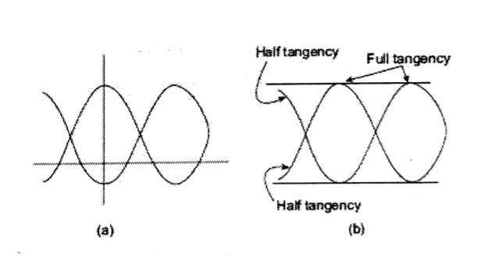

Figure-12 Lissajous pattern with half tangencies

The ratio of frequencies when open ended Lissajous patterns are obtained can also be found by treating the open ends as half tangencies as shown in Figure 3.13(b).

There are some restrictions on the frequencies which can be applied the deflection plates. One obviously, is that the CRO must have the bandwidth required for these frequencies. The other restriction is that the ratio of the two frequencies should not be such as to make the batter too complicated otherwise determination of frequency would become difficult. As a rule, ratios as high as 10:1 and as low as 10:9 can be determined comfortably.

**Measurement of Phase Difference:**

When two sinusoidal voltages of equal frequency which are in phase with each other are applied to the horizontal and vertical deflecting plates, the pattern appearing on the screen is a straight line as is clear from Figure 3.14.

when two equal voltages of equal frequency but with 90 phase displacement are applied to a CRO, the trace on the screen is a circle. This is shown in Figure 3.15.

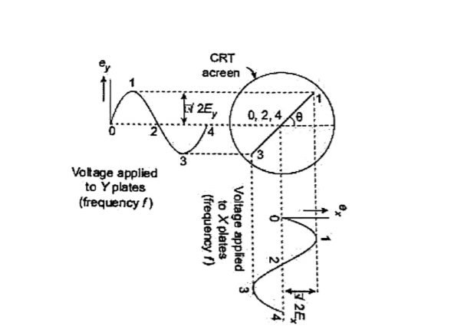

Figure-13 Lissajous pattern with equal frequency voltages and

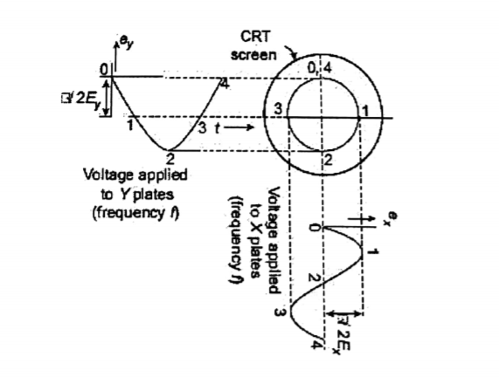

Figure -14 Lissajous pattern with equal voltages and a phase shift of

When two equal voltages of equal frequency but with a phase shift D not equal to 0 or 90) are applied to a CRO, we obtain an ellipse as shown in Figure 3.10. An ellipse is also obtained when unequal voltages of same frequency are applied to the CRO.

A number of conclusions can be drawn from the above discussions When two sinusoidal voltages of same frequency are applied, a straight-line result when the two voltages are equal and are either in phase with each other or 180 out of phase with each other. The angle formed with the horizontal is 45 when the magnitudes of voltages are equal. An increase in the vertical deflecting voltage causes the line to have an angle greater than 45° with the horizontal.

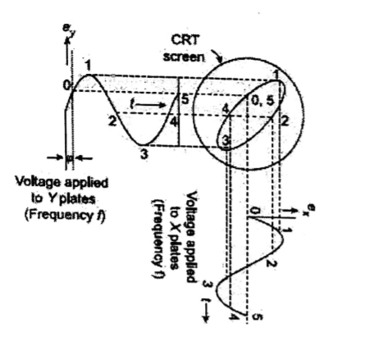

Figure-15 Lissajous pattern with two equal voltages of same frequency and phase shift of

Two sinusoidal waveforms of the same frequency produce a Lissajous pattern which may be a straight line, a circle or an ellipse depending upon the phase and the magnitude of the voltages.

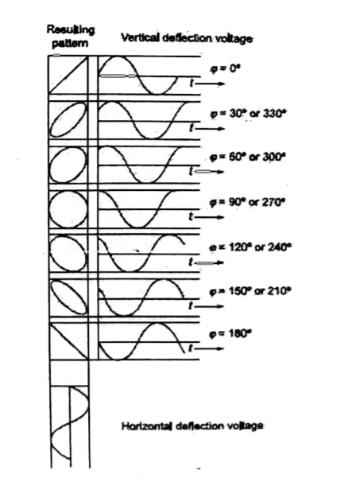

Figure-16 Lissajous pattern with different phase shift

A circle can be formed only when the magnitude of the two signals are equal and the phase difference between them is either 90° or 2709 However, if the two voltages are out of phase an ellipse is formed.

It is clear from Figure 3.17 that for equal voltages of same frequency, progressive variation of phase voltage causes the pattern to vary from a straight diagonal line to ellipse of different eccentricities and then to a circle, after that through another series of ellipses and finally a diagonal straight line again.

Regardless of the amplitudes of the applied voltages the ellipse provides a simple means of finding phase difference between two voltages. Referring to Figure 3.18, the sine of the phase angle between the voltages is given by

For convenience, the gains of the vertical and horizontal amplifiers are adjusted so the ellipse fits exactly into a square marked by the lines of the graticule.

If the major axis of the ellipse lies in the first and third quadrants (i.e.. positive slope) as in Figure 3.18 (a), the phase angle is either between 0° to 90° or between 270° to 360°. When the major axis of ellipse lies in second and fourth quadrants, i.e., when its slope is negative as in Figure 3.18 (b)the phase angle is either between 90° and 180° or between 180° and 270°.

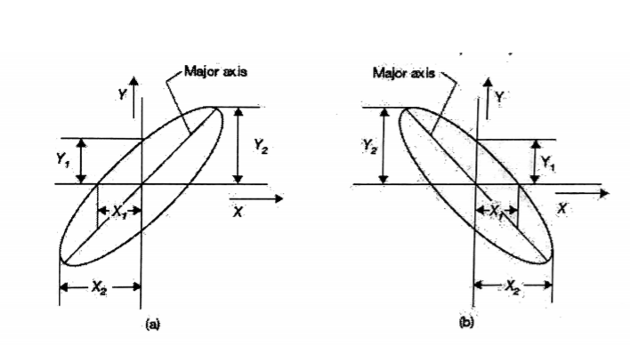

Figure-17 determination of angle of phase shift

**References**

1. "Cathode-Ray Oscillograph 274A Equipment DuMont Labs, Allen B" (in German). Radiomuseum.org. Archived from the original on 2014-02-03. Retrieved 2014-03-15.
2. Kularatna, Nihal (2003), "Fundamentals of Oscilloscopes", Digital and Analogue Instrumentation: Testing and Measurement, Institution of Engineering and Technology, pp. 165–208, ISBN 978-0-85296-999-1.
3. R. H. A. Farias, Liu Lin, A. R. D. Rodrigues, P. F. Tavares, and A. Hofmann

Phys. Rev. ST Accel. Beams 4, 072801 – Published 12 July 2001.

1. J. G. McQueen, Electronic Eng. 24, 436 (1952).
2. Germeshausen, Goldberg, and McDonald, Inst. Radio Engrs. Trans. on Electron Devices ED‐4, 152 (1957).